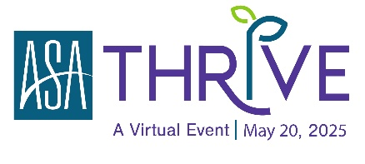

AI Power Play: Boost Your Staffing Success in 20-Minutes
Lauren B. Jones, founder and chief executive officer, Leap Advisory Partners

THRIVE Virtual Resources: https://americanstaffing.net/THRIVE2025-Resources

Speed Talk Resources:
- Session Slides
- Additional Resources:
- AI Prompt Library
- Jasper: AI Policy Template
- Course/Programs Offered Thru Leap Advisory Partners:
  - Learn More and Register: Masterclass for Leaders/Executives: June 11, 2025
- Supercharge your Desk with AI Course
- Connect with Lauren:
  - LinkedIn
  - Website

Additional AI Tools Mentioned During Speed Talk:
- CoPilot: https://copilot.microsoft.com/
- Perplexity AI: https://www.perplexity.ai/
- ChatGPT
- Pop AI: https://www.popai.pro/en/
- Gamma: https://gamma.app/
- Abacus ai: https://abacus.ai/
- Bot Press: https://botpress.com/
- Grok AI: https://grok.com/

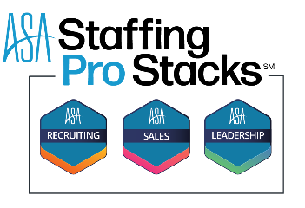

One week only! THRIVE 2025 Virtual attendees save 25% on ASA Staffing Pro Stacks!
Courses developed by Subject Matter Experts with decades of experience in Staffing.

Use Promo code: THRIVE4PROSTACKS

Learn More and Purchase: https://americanstaffing.net/asa-pro-stacks-programs/

