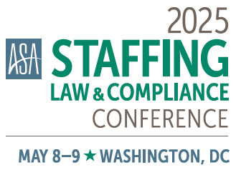

EXHIBITOR PROMOTION GUIDE

2025 ASA Staffing Law & Compliance Conference ▪ May 8-9,2025

Grand Hyatt ▪ Washington, DC

CONTACT ATTENDEES FOR FREE
As an exhibitor, you have the option to send a pre- or post-show email to attendees. This service is offered for marketing purposes exclusively to promote the exhibiting company’s participation at the 2025 ASA Staffing Law & Compliance Conference.

STEPS TO SEND PROMOTION
In line with industry best practices, ASA will no longer provide the attendee list in excel format. Instead, all promotions will be sent from ASA.

OPTION 1: Submit the HTML code for your email and it will be sent as-is.

OPTION 2: Use the ASA email template. Submit information using the below parameters:
- From email address
(ASA will need to send a verification email from Mailchimp in order to send the email on your behalf. Companies will need to have access to the email address supplied.)
- From name
- Email subject line
- Email preview text*
- Header or logo image
Maximum width of 650 pixels wide x 225 pixels height, .PNG or .JPG format
- Preferred color of hyperlinks and buttons
Please provide hex code, such as #906abf or #0000ff, or a simple color. Color of hyperlinks and buttons must be the same color.
- Headline*
with less than 38 characters
- Intro text
no more than 2 paragraphs
- Button text and hyperlink*
- Closing text
no more than 3 paragraphs
- Company’s full name, physical address, and phone number
for footer of email

*This information is optional

All promotional pieces must still include the 2025 Staffing Law & Compliance Conference logo and the website address staffinglawconference.net.

Click here to access a sample email using the ASA template.

DECIDE WHICH PROMOTION TO SEND
◻ Pre-Show List  available April 23–May 7 | ◻ Post-Show List  available May 12 – May 26

QUESTIONS?
Contact the Supplier Relations team:

Katie McGilvery
Expo Coordinator, Supplier Relations
kmcgilvery@americanstaffing.net

